Volunteer Rollover Screening

Overview
Many school districts have a policy that requires their active volunteers to be re-screened or background checked at least once every 12, 24 or 36 months. EZVolunteer is designed to keep a volunteer record in the database for their entire ‘career’ in your school district and keep track of the last time they were screened. This means volunteers do not need to re-register for the single purpose of background checking them.

Instead of purging your database of volunteers every year we recommend using the following approach to notify your volunteers and ask them to ‘opt out’ of future activities (and therefore re-screening) before you move forward with performing background checks on those that remain active in your database.

Opt Out Notification
The first step is to notify volunteers that you will be re-screening and offer them the option to opt out. Since this communication should come from the district office, and since you will be using it to connect with your entire database of volunteers we recommend using the Notices Module to create and publish your communications.
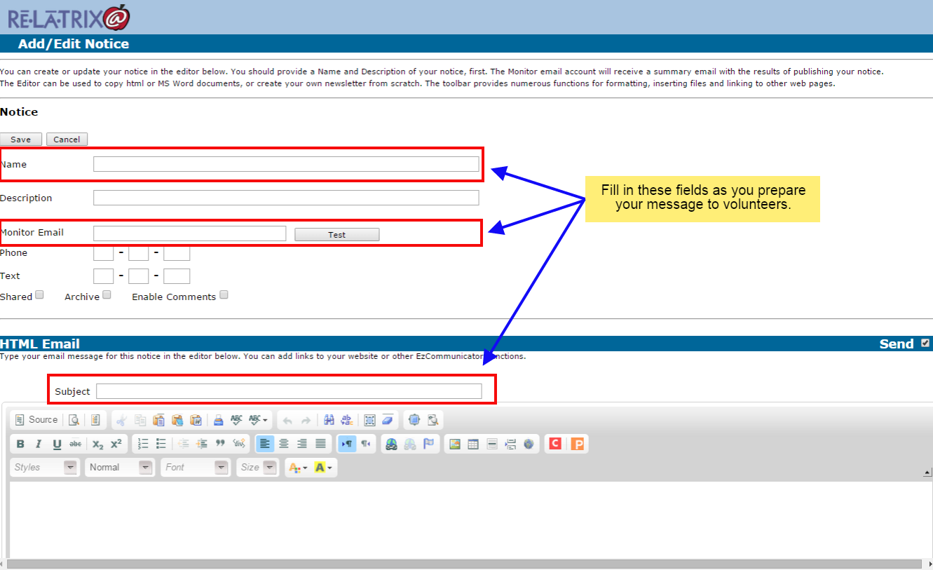
Start by going to Notices and using the Add Notice button to create a new notice. You can reuse this notice to remind your volunteers monthly or once a quarter or semester.
- Type a Name for the notice (Description is only necessary if archiving the notice)
- Type your email address as the Monitor Email so you can send yourself a test message
- Type the Email Subject for your message. Try something like ‘Please Let Us Know If You Will NOT Be Volunteering At <District_Name> This School Year’
- Create your email message to volunteers using the following as a starting point.
- Once you finish editing use the TEST button to save and send yourself a copy of the notice before you publish.

Dear <District_Name> Volunteer,
We appreciate your commitment to working with the students and staff in our schools. Your efforts are a crucial part of making education work at <School_District>.

As part of our district policy we require a periodic update to the background check that we have on file for all active volunteers. This update is required to be performed once each (year, two years, three years). This means that we will be submitting for background screening the information we currently have on your volunteer record.

We need your assistance to make this compliance requirement work smoothly. Therefore, we are requesting the following -
- If you WILL NOT BE volunteering during the coming/current school year use the link at the bottom of this email to SIGN-IN to your volunteer account. You will need your Username and Password for your volunteer account. If you do not remember your Username or Password click the I Cannot Login link and we will send them to you. Once signed in scroll to the bottom of your account page and check the box for ‘REMOVE ME’. Then press the SAVE button to update your account.

You will be excluded from our periodic background screening process and you will no longer be approved to volunteer in our schools. Should you decide later that you do wish to volunteer you will need to re-register at that time.

- If you WILL BE volunteering during the coming/current school year BUT your information (Name, Address, AKA/Aliases, Registered School, etc.) is not up-to-date on your record, please sign-in to your account and update those details immediately. If you do not remember your Username or Password click the I Cannot Login link and we will send them to you. By updating your volunteer information you also consent to our using your information for background screening purposes and understand we will use the results in determining final approval to volunteer in our schools.

- If you WILL be volunteering during the coming/current school year and you know your volunteer information is accurate and up-to-date, you do not need to take any further action. You consent to our using your information for background screening purposes and understand we will use the results in determining final approval to volunteer in our schools.

It is important that you take action, as requested above no later than <DATE_CERTAIN> so we can proceed with the background re-screening process for active volunteers. If you have any questions about the details of this email or have any technical difficulties updating your account, please contact the volunteer services/partners in education office by email at <VIPS@YourDistrict.net>.

Thank you again for your commitment and contribution to the success of our community and family engagement efforts at <District_Name>.

Sincerely,
Volunteer/Partners Department

Publishing Your Notice
After you have created and saved your notice you should publish it to your active volunteers. You can do this one of two different ways.

Either publish from the Notices List Page, where you can filter to all school volunteers, or publish from your Volunteer List page where you can filter your volunteers and select the notice you want to send them. The advantage of the Notice List option is you can schedule the notice to go out at a later date/time. The advantage of the Volunteer List option is you can filter by volunteer affiliations and interests.

To Publish From Your Notice List Page -
- After verifying your notice looks the way you want, click the Publish icon for the Notice you have just created. This will take you to the Publish Filter page.
- Scroll down to the School Relationships section and choose VOLUNTEER in the AVAILABLE Relationships Box and then (holding down the SHIFT Key) choose all schools from the AVAILABLE Schools to whom you want to send your notice.
- Click the Add button to move all the school volunteers to the list of SELECTED School Relationships.
- At the bottom of the page choose FILTER LIST >> to go through the database and filter your volunteers.
- On the Verify Results page check the Number Of Users to be sure your filter selection was correct, then either Schedule for later publishing or click the PUBLISH >> button to publish immediately.

To Publish From Your Volunteer List Page -
- After verifying your notice looks the way you want, check the Filter/Search All Schools box to make certain you will be sending to all school volunteers
- Filter By Opportunity Type/Affiliations using the dropdown option
- Use the SELECT ALL link to choose all filtered volunteers
- From the Choose An Action dropdown choose Send Notice
- Select the notice you created and click the GO button

(Note: Regardless of the method you choose to publish your notice you should look at the Notices List Page after your email has gone (usually 1 - 4 hours later) and see if there are any email bounces. Click on the number in the Bounces column to see a list of the volunteers’ who did not receive your Opt Out message. You can fix their email address, if bad and resend the notice or take other action to follow up by phone or snail mail.)

Creating A Re-Screen List
Once you have notified your volunteers and given them time to opt-out of volunteering in the current/coming school year you should create your re-screen list(s). While you can create a list of your entire database of active users, we recommend as a best practice to do the re-screen on a monthly basis. There are a couple advantages to this approach -

- It will allow you to send your Opt Out notice multiple times throughout the year, which will reinforce the need of volunteers to take action, if they are no longer active.
- It will allow you to Review any volunteers who return a hit on their record in a more timely manner. Remember, you volunteers didn’t all sign-up on a single day and so rescreening them on a monthly basis is more consistent with their initial registration screening.
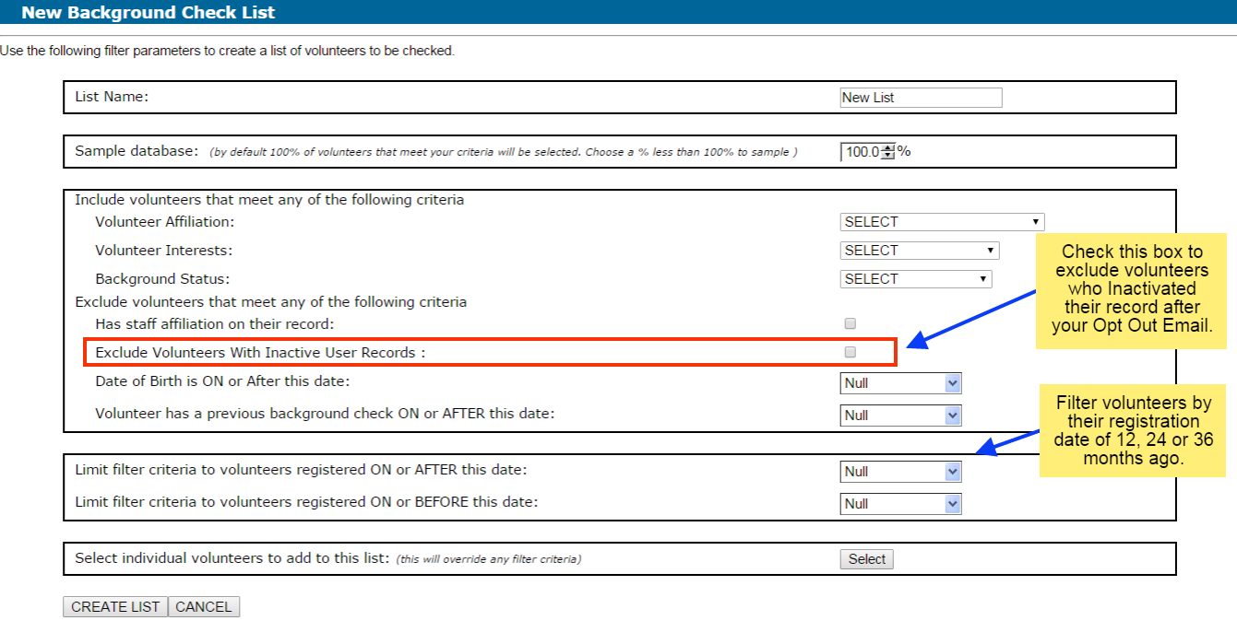
To create your monthly Re-Screen list follow these steps -
- Navigate to EZVolunteer > Utilities > Background Screening
- Click on the Create New List button
- On the New Background Check List page type a List Name
- Check the box to exclude Inactive Users
- Select the Start and End dates for the registration dates you want to rescreen
- Click the Create List button
This will redirect you to the list verification page where you will see all the volunteers that met your filter requirements. You can select and exclude any volunteers you wish before saving the list.

To Re-Screen your volunteers you will use one of the following sequence of steps, depending on whether you use our Real Time Screening with Backgroundchecks.com or a non-real time screening method with batch or 3rd party screening services.

For Real Time Screening follow these steps -
- From the Manage Background Check Lists Page click the Log Results link to view your list of Re-screen volunteers
- Use the SELECT ALL link to select all volunteers on your.
- From the Action dropdown choose Re-Submit to submit your list of volunteers

(NOTE: Lists of volunteers will be queued up and processed after re-submitting them from your Background Module. This may take several hours to complete, depending on the length of your list. Review Notifications will be sent to the administrator and volunteer if/when we receive results on a volunteer being re-screened.)

For Batch Screening follow these steps -
- From the Manage Background Check Lists Page click the CHECK button to submit your list to SterlingBackCheck OR
- From the Manage Background Check Lists Page click the EXPORT button to download a spreadsheet with your volunteers

The SterlingBackCheck service will update the results directly to your list and you will be able to see how many volunteers have a re-screened result by the Logged count on the Background Check Lists Page.

If you export your list then you will need to use the Log Results function when you have the Re-Screen results back so you can record any changes, along with the date of the new Background Check.

Repeat the above process on a monthly or quarterly basis until you have re-screened all your active volunteers and at the same time cleared out volunteers who no longer wish to volunteer.

If you have any questions, please contact Relatrix Customer Support by email at support@relatrix.com, or visit our website and use the Chat With Relatrix! Button or now you can chat from your admin console using the “?” icon on the top-right of your page.

